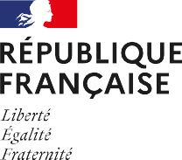





PRESS RELEASE

United Arab Emirates – 20/01/2026

France Showcases Food Innovation to Gulfood 2026 with 110 Leading Brands

Dual-venue French Pavilions reflects France’s strengthened agri-food presence and commitment to quality, sustainability, and market-ready innovation.

Business France, the public consulting agency serving the international development of the French economy, announces its strongest-ever participation at Gulfood 2026. In line with Gulfood’s dual-venue expansion between historic Dubai World Trade Centre and Dubai Expo City, France will present four Taste France Pavilions and its vision of a connected, intelligent food economy, showcasing premium food and beverage solutions that embody quality, sustainability, and innovation.

This year, France’s presence spans two key sites:
- World Food at Dubai Expo City (Booth 8-80): 67 companies
- Dubai World Trade Centre: 43 companies
  - Dairy – Sheikh Rashid (Booth R-H47)
  - Meat, Poultry & Seafood – Sheikh Saeed Halls (Hall 3)
  - Beverages – Za’beel Hall 5 (Booth Z5-J21)

This expanded footprint reflects France’s commitment to offering world-class products that meet the evolving needs of Middle Eastern markets. Buyers, importers, and distributors will discover authentic, trend-driven, and competitive solutions rooted in quality and sustainability.

Innovation & Excellence at the Core of the French Pavilion

The French Pavilions will feature four high-potential categories: non-alcoholic beverages, meat, poultry & seafood, dairy products, and World Food specialties. This year introduces numerous new exhibitors and exclusive launches, affirming France’s ability to anticipate and shape global consumption trends.

Visitors will encounter:

- Portioned formats for on-the-go lifestyles
- Health-forward innovations
- Gourmet offerings blending indulgence and functionality

Notable brands debuting at Gulfood include: Idalia, Bitecone, Biscuiterie de la Chapelle (Florentins), Hafner, Cerealia, Soleil Créole, Sainte Lucie, Société Astruc, Cookie Creations, Sias Alsace, Mix Buffet, Timeshaker, Distillerie Combier, Soofty Drink, Porketto, and Gourmet de Paris. These exhibitors offer a unique intersection of heritage, traceability, and creative innovation.

Beyond product displays, France’s participation serves as a strategic business accelerator for sourcing premium offerings – from organic dairy produced with ethical farming standards, to halal-certified beverages and artisan meats that combine tradition with innovation.

“Gulfood 2026 is a pivotal platform to reaffirm France’s excellence in agri-food,” said Axel Baroux, Managing Director of Business France Near & Middle East. “With our largest-ever footprint across two venues, we are proud to present 110 brands that reflect France’s strength in quality, innovation, and sustainability. This is a unique opportunity for regional buyers to source standout products that deliver market relevance and competitive edge.”

France Aligned with UAE Food Trends

The UAE imports 85% of its food, amounting to over €21.4 billion in 2024. As the market evolves, there is increasing demand for:

- Ready-to-eat formats
- Gourmet and functional foods
- Organic, plant-based, and traceable options
- E-commerce-friendly products

French companies are uniquely positioned to meet these needs with high-value propositions adapted to GCC consumer behavior, including portion-controlled meals, health-conscious snacks, and culinary solutions merging taste and practicality.

Immersive Culinary Journey at the Pavilion

This year’s Pavilion promises a curated gastronomic experience featuring live culinary shows, interactive tastings, artisanal coffee and tea rituals. From French-Emirati fusion dishes to premium beverage demonstrations, every session is designed to offer replicable recipes, pairing inspirations, and hands-on engagement for industry professionals. Expect a vibrant, multi-sensory experience balancing bold flavors and delicate presentations.

Business France Marketplace: Sourcing Made Simple

Business France continues to enhance B2B connections with its Marketplace platform, linking global buyers with 2,800+ vetted French suppliers and 28,000+ premium products.

“Nearly 350 regional buyers have already joined the platform,” said Axel Baroux. “This initiative is a game-changer for seamless sourcing and long-term partnerships.”
To know more: marketplace.businessfrance.fr/event/index/sellers/id/1017/

Why Visit the French Pavilion?

The French Pavilion is a must-visit for professionals seeking:
- Exclusive product launches
- Next-gen innovation
- Ethical sourcing and sustainability
- Dynamic cross-cultural culinary experiences

With 110 pioneering exhibitors, immersive gastronomy, and a strong export-ready portfolio, France is not just participating, it is shaping the future of food in the Middle East.

Our partners

The French Pavilions are supported by the regional partner agencies Bretagne Commerce International, Food Loire, Dev’Up and AANA.

The French pavilions are sponsored by Evian, the world’s number one mineral water and Café Richard, a traditional coffee roaster.

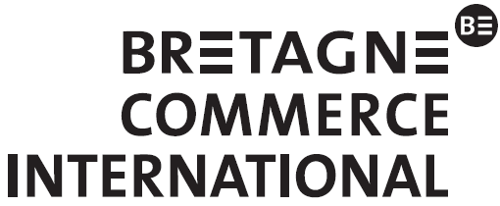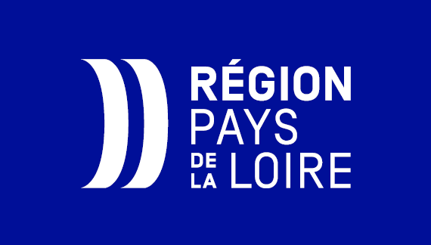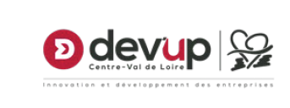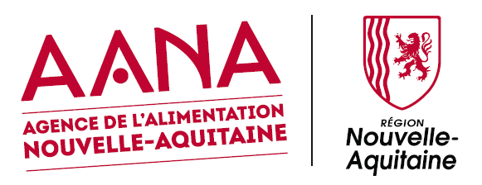

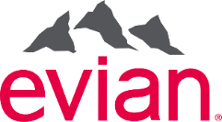
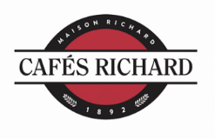

About business France:
Business France is the public consulting business serving the international development of the French economy. It is responsible for fostering export-led growth by French businesses, as well as promoting and facilitating foreign investment in France.

It promotes France’s firms, business image and nationwide attractiveness as an investment location, and also
runs the V.I.E program.

Business France has more than 1,400 personnel, both in France and in 53 countries throughout the world.

In 2024, support from Business France made it possible to generate €1.8 billion in additional export revenues for French SMEs and mid-size companies, accounting for more than 31,010 jobs created or planned. Business France supported 66% of the 1,688 foreign investment decisions in 2024, accounting for 69% of the 37,787 jobs created or maintained nationwide over the next 3 years.

What if the taste of France could be enjoyed all around the world?

Supported by the Ministry for Agriculture, Agri-Food and Food Sovereignty, Taste France showcases the very best of French agriculture, agri-food and gastronomy on the international stage.

More than just a brand, Taste France brings together all players in the sector, including businesses, producers, artisans and restaurateurs, which are united by a shared ambition:
to promote French excellence, savoir-faire and sustainability.

Beyond its products, Taste France embodies the French art of living and shared experiences, inviting everyone to bring our products into kitchens around the world with simplicity, creativity and authenticity.

Our core values:

Excellence
Responsibility
Pleasure
Authenticity
Innovation

Join us and take part in sharing the richness of France on every plate, all around the world!

For further information, please visit:

www.tastefranceforbusiness.com #TasteFrance @TasteFrance_EN https://x.com/TasteFrance_EN
https://www.linkedin.com/company/taste-france/

Press Contacts

Yasmina Ouari – Business France Dubai
Senior Communication Advisor
Email: yasmina.ouari@businessfrance.fr

