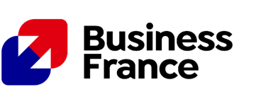
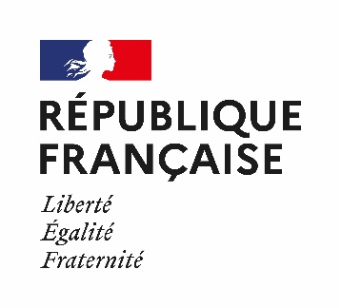

PRESS RELEASE

France Leads the Way in Sustainable Construction at Big 5 Global 2025

United Arab Emirates, 21 November 2026 - From November 24 to 27, 2025, 19 French companies will take part in Big 5 Global in Dubai, exhibiting within the French Pavilion, a key platform highlighting France’s excellence in sustainable construction, technology, and design.
At the French Pavilion, companies are shaping the future of construction in the Gulf with certified green materials, smart technologies, and advanced fire protection solutions. Their presence at Big 5 Global 2025 highlights France’s strong commitment to the region’s sustainable development, driven by innovation and technical excellence. Discover the full spectrum of French innovation, visit the France Pavilion and explore our dedicated platform: Homepage - BIG 5 Global 2025
A Booming Market with Strong Opportunities for French Expertise
The construction industry, a cornerstone of the United Arab Emirates’ economic diversification strategy, accounts for nearly 11% of national GDP. Valued at USD 95 billion in 2024, it is projected to reach USD 118 billion by 2030, with an average annual growth rate of 5%.
With over 10,700 active projects and bold initiatives such as the Dubai Urban Master Plan 2040 and Abu Dhabi Economic Vision, the UAE has established itself as the second-largest construction market in the Gulf, just behind Saudi Arabia.
Across the GCC, the scale is even greater: ongoing construction projects exceed USD 1.3 trillion, positioning the region as a global hub for infrastructure and real estate development.
Driven by ambitious national strategies and rapid urban expansion, with Dubai’s population projected to reach 6 million by 2040, the region is experiencing an unprecedented surge in demand for housing, infrastructure, and hospitality. At the heart of this momentum lies sustainability, now a key priority led by public authorities, developers, and major contractors.
For French companies, internationally recognized for their expertise in energy efficiency, advanced materials, and architectural innovation, this shift represents an exceptional opportunity to support the region’s sustainable urban transformation
The French Pavilion: Smart and Sustainable Solutions for Regional Needs
In this thriving context, the French Pavilion will showcase a wide range of innovative and responsible solutions tailored to the specific needs of Gulf markets, from bio-based materials, smart equipment, and low-carbon design to eco-engineered professional tools and 3D mapping technologies.
Several exhibitors will present solutions addressing key regional challenges such as heat management, ventilation in high-risk environments, and air quality in industrial, healthcare, and hospitality settings.
Through its France 2030 plan, the French government is mobilizing innovators to address major challenges such as industrial decarbonization, economic transformation, and national sovereignty, priorities that closely align with the Gulf region’s focus on energy transition, industrial innovation, and sustainable construction. The France 2030 innovation program accelerates this momentum by supporting researchers, start-ups, and SMEs with funding, mentoring, and visibility to develop the sustainable solutions of tomorrow.
Three of this year’s French Pavilion exhibitors are proud France 2030 program funded companies:
- FEHR GROUP – ARTEMIX, introducing the world’s first mobile, autonomous, and automated ready-mix concrete dispenser, enabling flexible and low-carbon production.
- NOVACEL, presenting its OXYGEN range of eco-designed protective films, which reduce carbon emissions by up to 80%.
- OLIKROM, showcasing LuminoKrom®, the world’s only photoluminescent paint providing up to 10 hours of glow , enhancing safety and supporting sustainable mobility.
Under the French Fab label, the French Pavilion is organized by Business France, the national agency supporting the international development of the French economy, in partnership with Air France Industries KLM Engineering & Maintenance, Ubigi, and Terracota.
Our exhibitors :
AIRVANCE - ARIADIS - ARTEMIX - ART HOME ALU - CHAUX DE SAINT ASTIER - CTRE SCIENTIFIQUE TECHNIQUE DU BATIMENT - GEO-STAFF - GV2 VEDA France - GUARD INDUSTRIE - HAEMMERLIN SAS - IBS EVENT / INNOPOLIS - NEOLIFE - NIDAPLAST - NOVACEL - OLIKROM - PISCINES MAGILINE - QUADRA 1 - TALIAPLAST - YELLOWSCAN
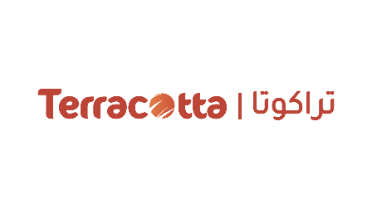
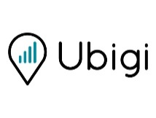
Ours partners :
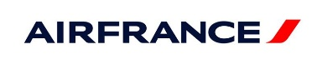

About Business France
Business France is the public consulting business serving the international development of the French economy. It is responsible for fostering export-led growth by French businesses, as well as promoting and facilitating foreign investment in France.
It promotes France’s firms, business image and nationwide attractiveness as an investment location, and also runs the VIE international internship program.
Business France has more than 1,400 personnel, both in France and in 55 countries throughout the world.
In 2023, support from Business France made it possible to generate €3.3 billion in additional export revenues for French SMEs and mid-size companies, accounting for more than 27,111 jobs created or planned. Business France supported 58% of the 1,815 foreign investment decisions in 2023, accounting for 67% of the 59,254 jobs created or maintained nationwide.

For more information, visit www.businessfrance.fr @businessfranceme #BusinessFrance

For media inquiries, please contact:
Hajer Bchir
Communications Advisor
Mail : hajer.bchir@businessfrance.fr

