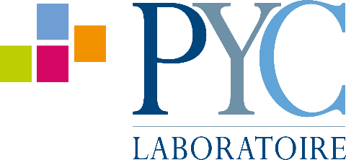
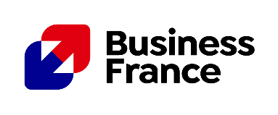

Laboratoire PYC reinvents nutricosmetics at Beautyworld Middle East 2025

United Arab Emirates – October 2025 - Laboratoire PYC, a French expert in contract manufacturing of dietary supplements and nutritional products, renowned for its excellence in flavor development, will participate in Beautyworld Middle East from October 27 to 29, 2025. The contract-manufacturer will exhibit at the Dubai World Trade Center, at the French Pavilion S2-D11, to showcase its latest "beauty-from-within" formulations.

Collagen innovations: three groundbreaking new products…

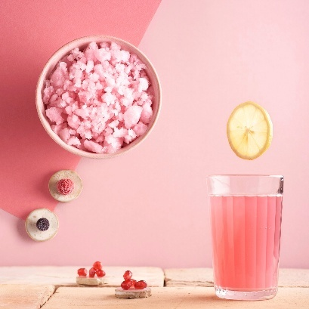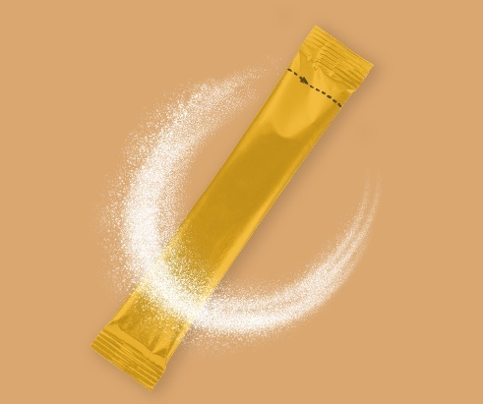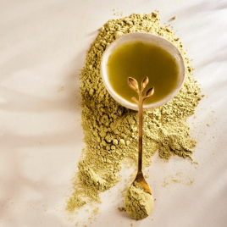

On the occasion of the trade show, Laboratoire PYC will unveil three unique collagen-based formulations, all designed and manufactured in France. These innovations, available as orodispersible powder, sparkling drink and infusion, reflect consistent scientific rigor, ease of use and a strong focus on taste quality.

REVOLISTIC COLLAGEN®
This first orodispersible collagen powder can be taken without water. Convenient and flavored with blackcurrant, vanilla, or pear, the formula contains 45% bioactive peptides, offering four times the concentration found in standard collagen. Enriched with highly bioavailable dipeptides and tripeptides, it melts directly in the mouth for a quick and sensory experience.

COLLAGEN PINK LEMONADE
This sparkling drink with a pink lemonade flavor contains 15 grams of French collagen. It is low in sugar and fat. The peptides it contains have been clinically proven to improve wrinkles, skin elasticity, and hair strength.

COLLAGEN SKINFUSE®
A range of six collagen-infused powdered teas and infusions that combine inner well-being with outer beauty. The selection includes flavors such as mint green tea, jasmine green tea, vanilla black tea, spiced black tea, matcha, and chamomile infusion.

... and many more beauty solutions to discover

In addition to its collagen formulations, Laboratoire PYC presents an exclusive haircare innovation based on plant-derived phytoceramides.

HAIR BLOOM CERAMIDES®
A powdered formula to be diluted, made from plant extracts, zinc, vitamin B8, and patented Ceramosides™ phytoceramides. Its proven effectiveness over three months includes improvements in hair growth (+12%), hair strength (+97%), and sebum reduction (-12%). With a clean label composition, natural Herbal Bliss flavor, and optimal solubility, it offers a highly effective solution.

The Middle East, a high-potential market for nutricosmetics

In an environment characterized by a harsh climate and high demands for beauty care, the Gulf market stands out as a genuine growth driver for nutricosmetics. Consumers are seeking natural and effective solutions that can truly address the needs of their skin and hair. Thanks to its clean label approach, aromatic excellence, and ability to create custom formulations, Laboratoire PYC meets these local needs.

“Over the past few years, we have observed a growing global demand for holistic beauty, with an increasing interest in collagen-enriched dietary supplements aimed at skin and hair beauty. In this region, there is a strong focus on beauty and wellness, and the rise of specialized brands and distributors in dietary supplements reflects this demand.
Laboratoire PYC supports brands looking to grow and differentiate themselves in this sector by offering tailored formulation, production, packaging, and private label services. We develop products with a distinctive sensory signature that enhances the user experience and encourages long-term loyalty,” says Aurélie DE SCHUYTENEER, Marketing and Communications Manager at Laboratoire PYC.

Contact

Aurélie DE SCHUYTENEER – Laboratoire PYC Yasmina OUARI – Business France
Responsable Marketing Chargée de développement
aurelie.deschuyteneer@laboratoire-pyc.com yasmina.ouari@businessfrance.fr

About Laboratoire PYC
With over 40 years of expertise, Laboratoire PYC designs high-value nutritional products, available as white-label or customizable solutions tailored to the specific needs of partner brands. All formulations are developed and manufactured in France using carefully selected ingredients with proven efficacy. Certified ISO 22000, the laboratory stands out for its unique aromatic mastery, a true taste signature of its formulations.

About the Solina Group
Laboratoire PYC is a subsidiary of the Solina Group, a global leader in the ingredients industry, with 4,000 employees across 43 production sites and R&D laboratories in 18 countries.

