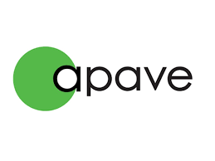



PRESS RELEASE
Apave Group expands its UAE presence
with new laboratory in Abu Dhabi

Abu Dhabi, September 10, 2025
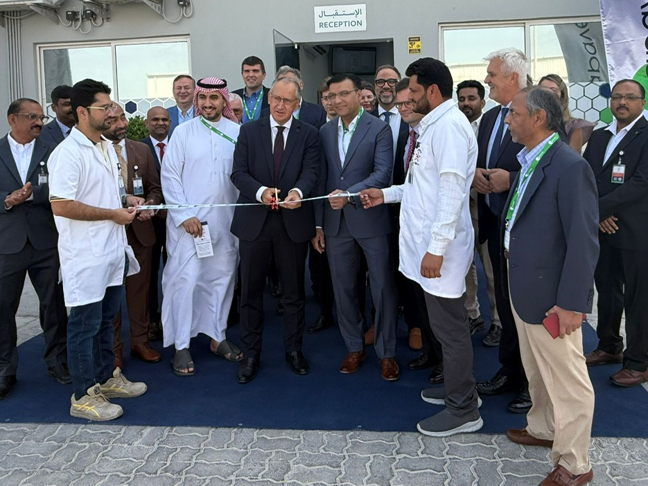 | 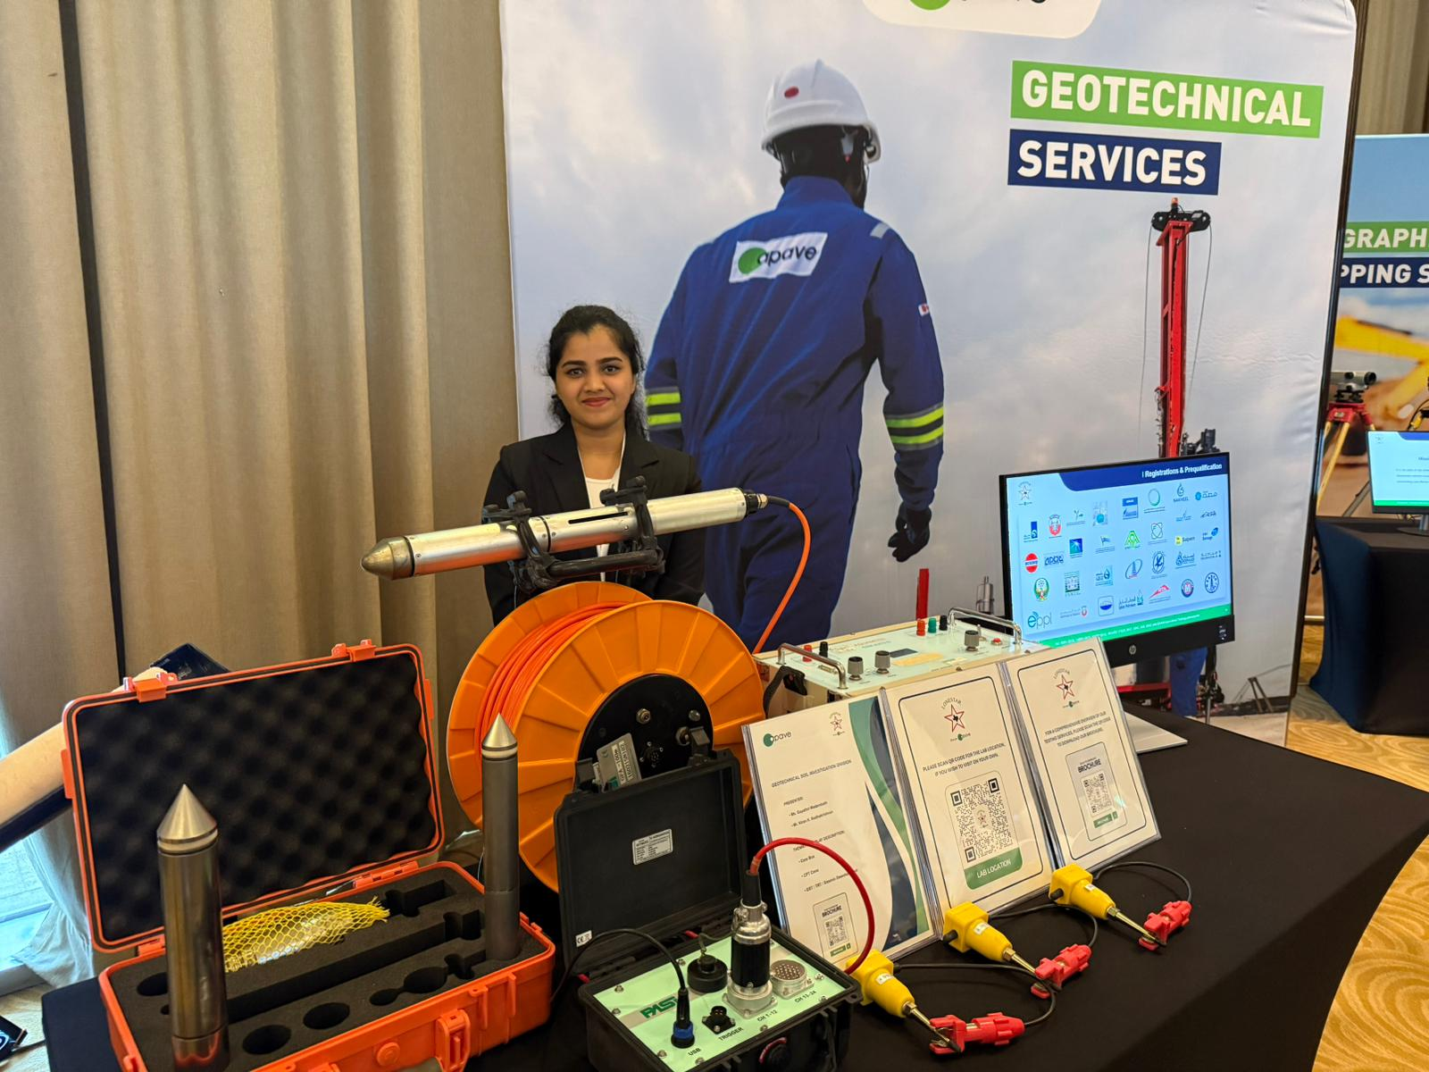
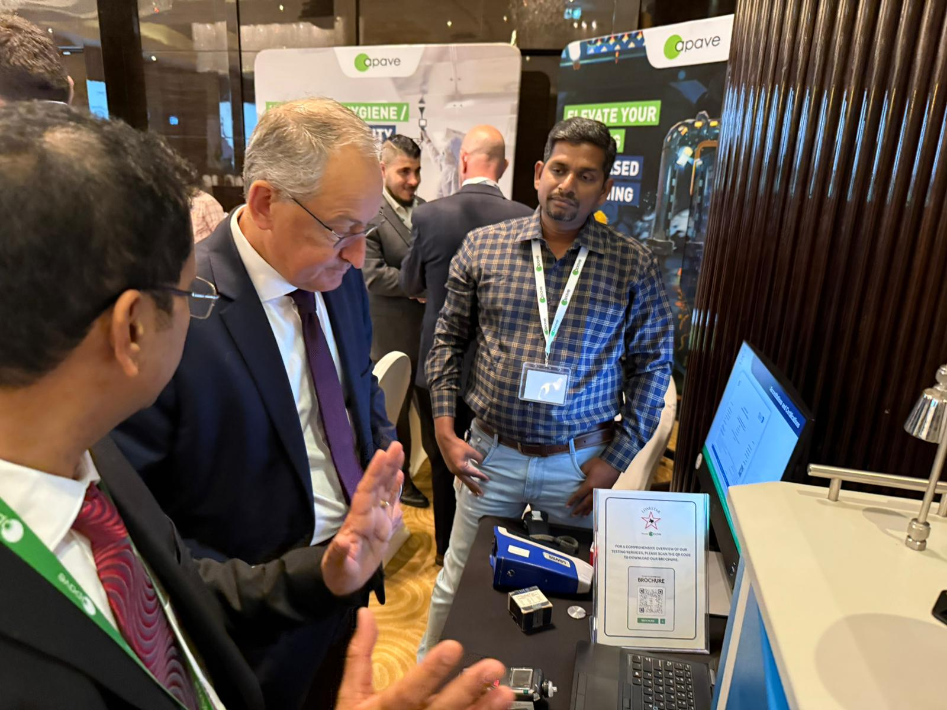 | 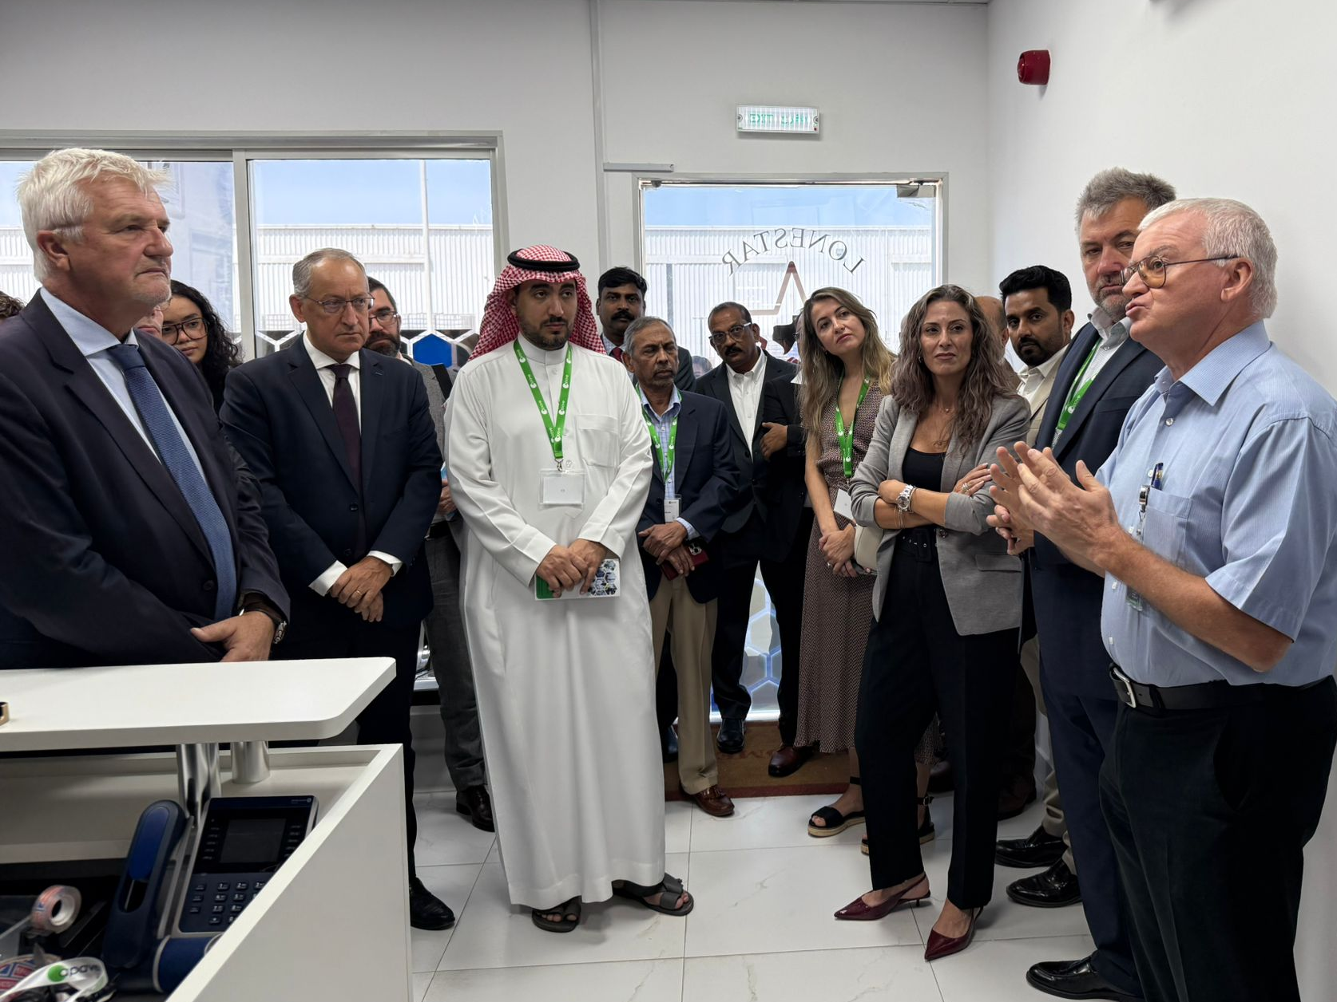

Apave Group, a global leader in risk management with over 150 years of experience, is proud to announce the inauguration of its new, advanced testing laboratory in Abu Dhabi. This new facility marks a significant expansion of the group's capabilities and reaffirms its commitment to the UAE market.
Led by Mr. Philippe Maillard, Apave Group CEO, and Mr. Muffakham Shareef, Managing Director of Apave-Lonestar, nearly 120 guests attended the inauguration of the new facility. Some had the opportunity to tour the advanced laboratory, before exploring thematic stands highlighting Lonestar’s and Apave’s expertise. From geotechnics and topography to civil construction, mechanics, and analytical chemistry, specialists were on hand to showcase the Group’s enhanced capabilities, answer questions, and demonstrate how Apave is ready to meet the rising demand in the UAE.
An Extensive Roadmap for Growth in the UAE and the Region
The Apave Group's presence in the UAE has been comprehensively strengthened since 2023 through a series of key strategic integrations. These include the re-establishment of Apave's operations via
- the acquisition of TIV (Technical Inspection Verification) – (previously the ABS Group's technical inspection and verification business line),
- an increased majority stake in Certifer, a French expert in rail and guided mobility recognized as an Independent Safety Assessor (ISA) for the Road and Transport Authority,
- and the acquisition of Lonestar, a leading local player with over three decades of experience in laboratory and geotechnical testing.
The new site in Abu Dhabi, launched today, is a testament to the combined strength of these entities.
“The Middle East, and the UAE in particular, is an important country for the Apave Group, in which we have invested heavily in recent years, notably with the integration of the TIV and Lonestar teams. Through the inauguration of the new Abu Dhabi laboratory, we confirm our desire to continue accelerating this development and to further support the economic growth of the region.
The needs are immense. Apave will ensure the success of all projects thanks to its deep understanding of the country and the strength of its international network," said Philippe Maillard, CEO of the Apave Group.

Equipped with state-of-the-art instruments the laboratory sets new standards in accuracy and reliability in the areas of civil / construction material testing, geotechnical soil investigation, and topographic surveys providing critical testing functions that will help reinforce the UAE’s commitment to innovation, safety, and sustainable industrial development.

Rising demand for testing and certification in a diversified UAE economy
In 2025, the UAE testing, inspection, and certification (TIC) market has become a strategic pillar of the country’s industrial growth. Valued at USD 2.37 billion in 2024 and projected to expand steadily through 2030, the sector is being driven by increasing consumer safety demands, stricter regulations, rapid technological change, and the globalization of trade. TIC services are now essential to ensure that products, systems, and services comply with standards and safety protocols, particularly as industries such as manufacturing, construction, automotive, aerospace, and healthcare grow at an unprecedented pace.
With more than 300 testing solutions, Apave’s new laboratory in the heart of Abu Dhabi marks the completion of nine months of work and an investment of 2 million AED. This milestone strengthens Apave Group’s position as a comprehensive partner for risk management in the UAE and provides vital support to the country’s ambitious economic and development strategies. Designed to meet the expectations of leading UAE companies that trust us, such as ADNOC, ENEC, and Emaar, the new facility reflects the Group’s strong commitment to advancing the national economy and fostering local industrial growth.
These developments strengthen Apave’s presence in the UAE with over 650 local employees, supported by the Group’s global expertise to deliver solutions tailored to local realities.

About Apave
Apave is France's leading trusted third party. An international group with over 150 years of experience specialising in technical, human, environmental and digital risk management. An independent company with a turnover of €1.4 billion in 2024, Apave now has 18,000 employees, including 12,000 engineers and technicians, 130 branches in France, and 180 training sites in France and abroad, which train more than 630,000 trainees per year. Apave has an international presence in nearly 60 countries. For more information, please visit: www.apave.com

For Media Enquiry
Hajer Bchir
Senior Communication Advisor at Business France Middle East
Hajer.bchir@businessfrance.fr

Anne Pluvinage-Nierengarten
Director of Institutional and Media Relations
Communication.presse@apave.com

