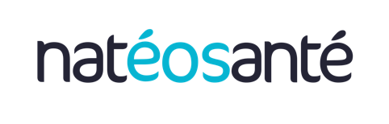

PRESS RELEASE

NatéoSanté at Arab Health 2025: French innovation in air quality showcases its expertise in Dubai

United Arab Emirates- January 2025 – NatéoSanté, a specialist in designing and manufacturing professional indoor air measurement and purification solutions, will unveil its latest innovations, including the EOLIS Air Manager air purifier, at the Arab Health exhibition from January 27 to 30, 2025. The French brand will exhibit at the Dubai World Trade Center, in the France Pavilion, Hall Za’abeel 2 (Z2.B19).

NatéoSanté ensures the performance of its air treatment units, which are tested and validated by independent French laboratories. These mobile and compact devices are easy to integrate and require no installation work.
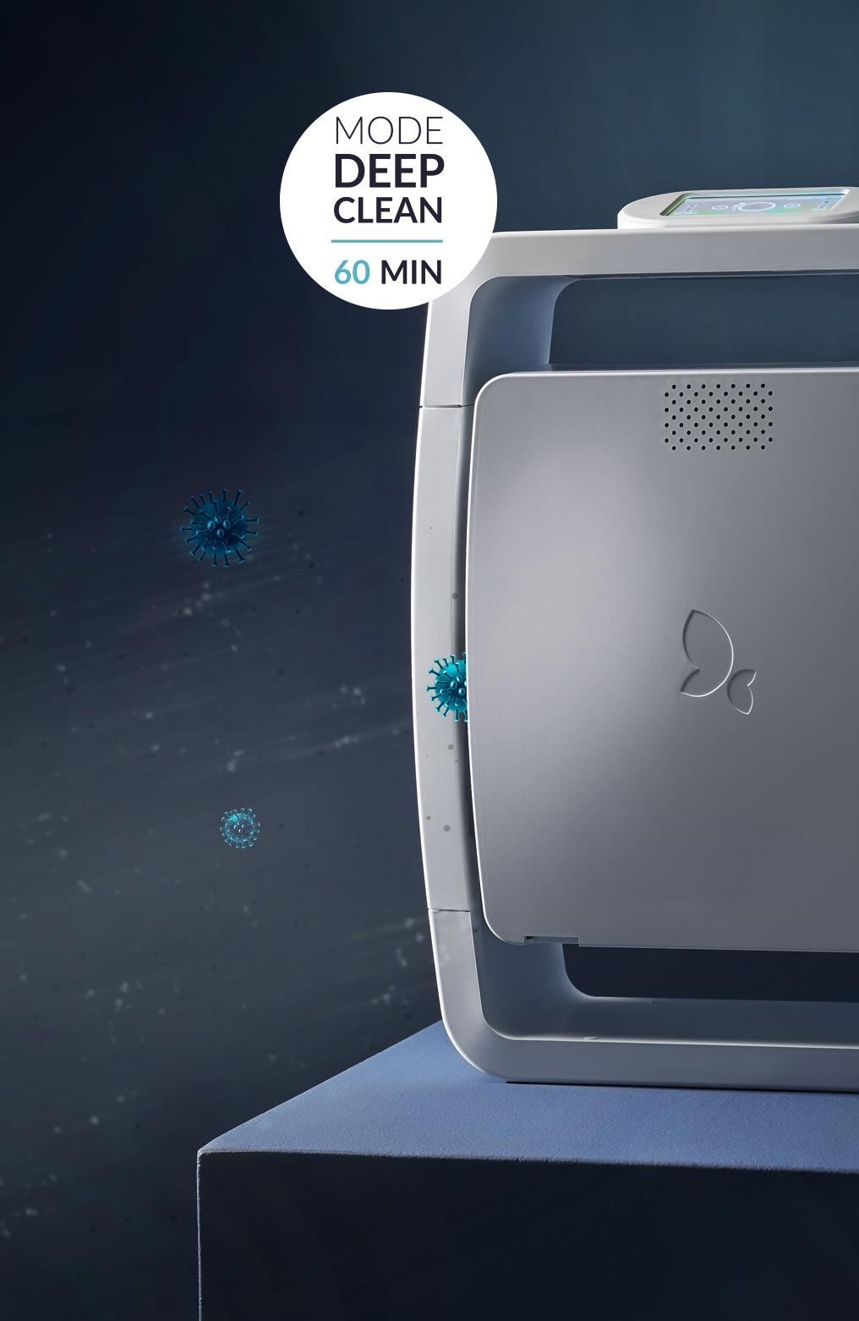
EOLIS Air Manager: an innovative and intelligent solution

Among the innovations presented, the EOLIS Air Manager air purifier stands out for its innovative and intelligent approach. This device combines advanced technologies, including medical-grade HEPA H13 filtration, a high-density activated carbon filter, an oxidation filter paired with UV-C lamps, and an advanced monitoring system to ensure clean air in all circumstances.

A key feature of the EOLIS Air Manager is its exclusive controlled active oxygen technology, Deep Clean. This process deeply purifies both air and surfaces to reduce the risk of cross-contamination.

A key player in the prevention of respiratory and hospital-acquired diseases...

As an active member of the French Healthcare Association, NatéoSanté contributes to the prevention of respiratory diseases, both occupational and non-occupational, as well as healthcare-associated infections (nosocomial) related to air quality through its cutting-edge technologies. Since 2009, the company has equipped over 500 establishments in France and abroad, playing a vital role in health protocols aimed at ensuring a healthy and efficient environment.

This commitment to health and well-being is accompanied by a strong sense of social responsibility. In 2022, NatéoSanté was awarded the Ecovadis Gold Medal for its CSR approach, a label that helps professionals make more sustainable purchasing decisions.
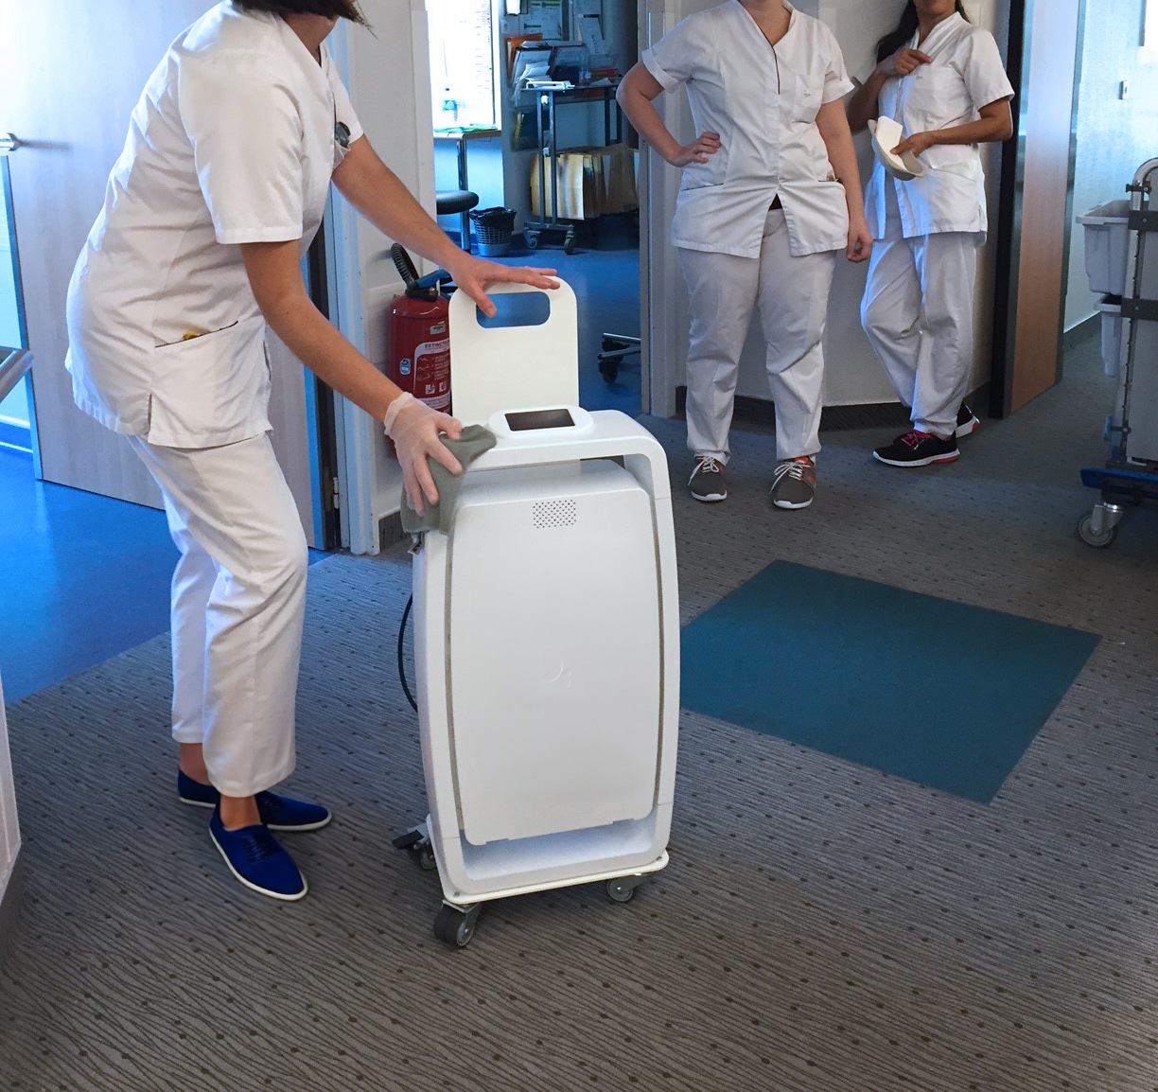
... with an international reach

NatéoSanté generates 42% of its sales from exports, with equipment installed in over 50 countries. The company is actively involved in integrating environmental hygiene into hospital health protocols around the world.

The Middle East: a land of opportunity for NatéoSanté

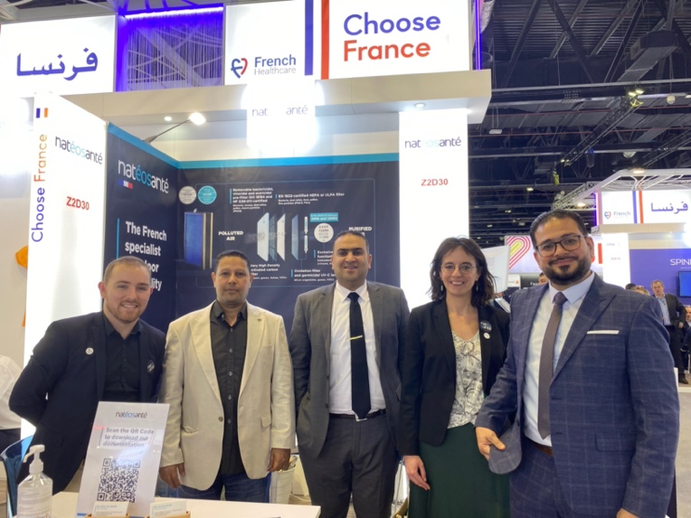
Since 2017, NatéoSanté has been a loyal participant in Arab Health, the leading trade show in the medical sector in the Middle East. This world-renowned event represents an opportunity for the French company to showcase their innovations to distributors and potential end-customers in the region.

In the United Arab Emirates, air pollution is a major challenge, exacerbated by the climate and dust. NatéoSanté positions itself as an essential solution, thanks to its medical-grade air treatment systems. As such, the brand stands out as an ideal solution to meet the specific needs of Emirati consumers.

Visit NatéoSanté at Arab Health 2025, where the company will showcase its French expertise and provide visitors with the opportunity to discover its innovations. Join us at the France Pavilion, Hall Za’abeel 2 (Z2.B19).

Press Contact

Anaïs DAVID - NatéoSanté Yasmina OUARI – Business France
Chief Operating Officer Press Officer
anais.david@nateosante.com yasmina.ouari@businessfrance.fr

About NatéoSanté
A French designer and manufacturer of indoor air measurement and treatment solutions, NatéoSanté has been supporting professionals since 2009. The company innovates in the prevention of respiratory diseases, both occupational and non-occupational, as well as healthcare-associated infections (nosocomial). Committed to eco-design and local production, NatéoSanté works every day to empower individuals to control the air they breathe through the excellence of its technologies and its performance guarantee. A pioneer in its field of expertise, NatéoSanté has made it its mission to "protect health and life through air."

