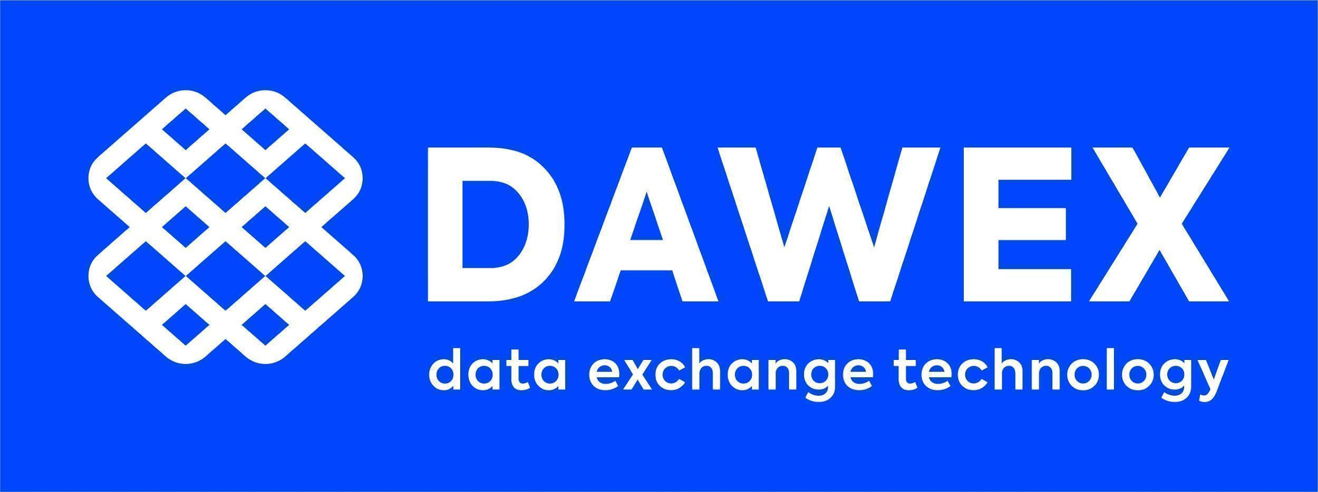
PRESS RELEASE

MGTS Creates the First Data Marketplace Specialized in the Automotive and Individual Mobility Sector Relying on
Dawex Data Exchange Technology

MGTS, Mobivia's international referencing and trading center, launches its data marketplace with the ambition to centralize information related to the automobile and individual mobility sector.

United Arab Emirates - May 11, 2022 - Dawex, the leading technology company for data exchange, data marketplace and data hub, unveils the MGTS Data Marketplace, the first non-personal data marketplace for the automotive sector (distribution, sales, use, wear and tear, maintenance and equipment), and more globally for individual mobility. The MGTS Data Marketplace aims at bringing together all stakeholders and observers of today's and tomorrow's individual mobility to enable its users to understand, anticipate and innovate in this rapidly changing sector.
Present in 18 countries with 2,000 customer contact points under the Midas, Norauto and ATU multi-brand car maintenance banners, Mobivia is the leader in its sector with over 50 million customers per year and 50 years of existence.
"Dawex provided us with the technology solution to monetize and generate value from our data or those of our partners, by creating a Data Exchange Platform that is powerful, efficient, secure and easy to use," explains Ludovic Codeluppi, International Product Leader at MGTS.
The MGTS Data Marketplace leverages Dawex Data Exchange technology to facilitate the collection, centralization, distribution, exchange and monetization of non-personal data in this sector. The different market players keep control over their data, decide with whom to share it and for what purposes, in an environment that guarantees security and traceability. Thanks to Dawex business and regulatory expertise, the MGTS Data Marketplace meets the requirements of European and international regulations, and is perfectly in line with the future Data Act.
"In less than a year, MGTS has built strong relationships with organizations outside of our immediate ecosystem thanks to Dawex introductions," continues Ludovic Codeluppi. "The circulation and commercialization of data between these stakeholders will play a key role in the development of new business models.”
Dawex technology enables MGTS to orchestrate and animate a vast data ecosystem from the automotive and mobility sector. It provides its stakeholders with the means to better understand and improve their user experience, increase productivity and efficiency, and boost innovation. The MGTS deployment is another illustration of Dawex technology leadership, demonstrating the footprint of its solid reference architecture.
"Data exchange has become a fundamental component of business competitiveness and economic sovereignty," comments Fabrice Tocco, Dawex co-CEO. "Organizing the circulation and monetization of its data within its ecosystem is an imperative for all players in the retail sector.”

Sign up to the MGTS Data Marketplace

About Dawex
In today’s economy where data has become a product of unlimited potential, with its own value, and a source of new revenue streams, Dawex technology allows organizations to create new ecosystems around data exchange platforms that meet regulatory requirements and address traceability and security challenges. Dawex is the leading technology company for data exchange, data marketplace and data hub to orchestrate the sourcing, the distribution and the exchange of data. Awarded Technology Pioneer by the World Economic Forum in 2020, Dawex is an active member of Gaia-X. Created in 2015, Dawex is headquartered in France, expanding business operations to Europe, Asia, North America and the Middle East.

Contact Presse : press@dawex.com

